**SIS Fluid – User Guide**

* **Sign-in Page redesign.**

The sign-in page of Campus Solution 9.2 is redesigned to reflect the LJMU theme, and a new fluid homepage is configured as below.

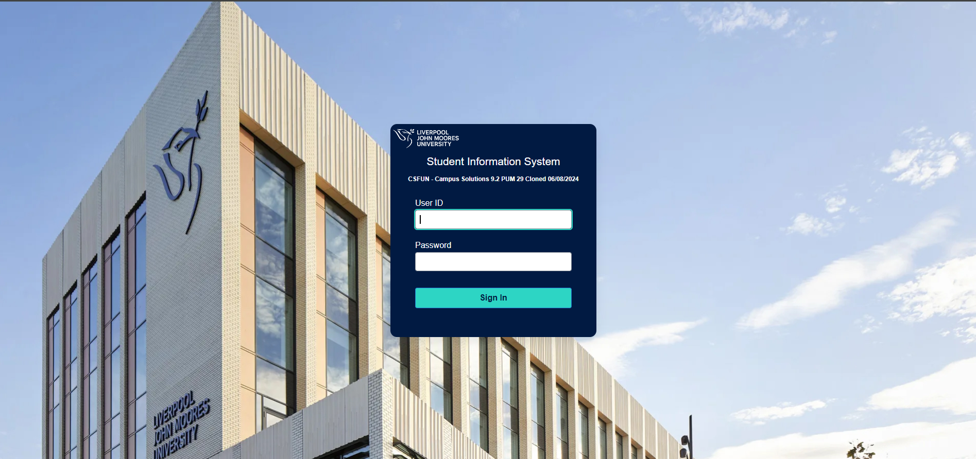

* **Fluid** **homepage**

New fluid staff homepage dashboards are configured, which will be governed by existing security roles. The staff homepage features have multiple tiles, and behind these tiles, there is either Campus Solution pages or fluid navigation collections that link to multiple pages. Additionally, templates and notifications are updated to reflect the LJMU branding.

After login we will be able to see staff homepage as default homepage as shown below.

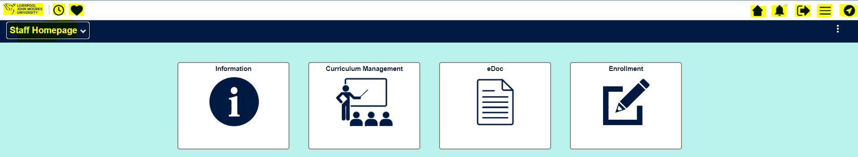

* **Icon Details**

The highlighted icon details are as below:

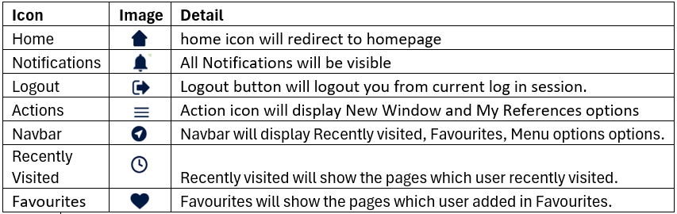

**New Features in Fluid**

* **Logout**

**Logout** button will logout you from current log in session.

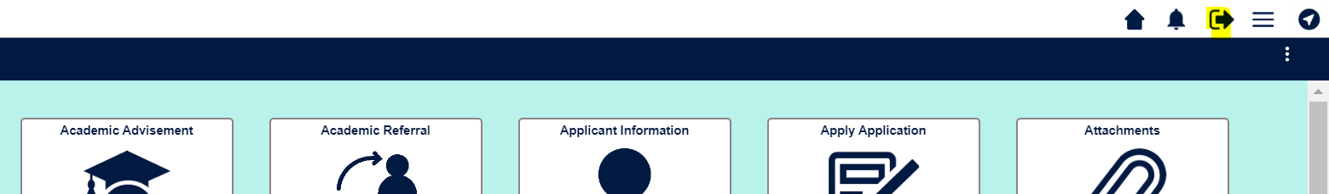

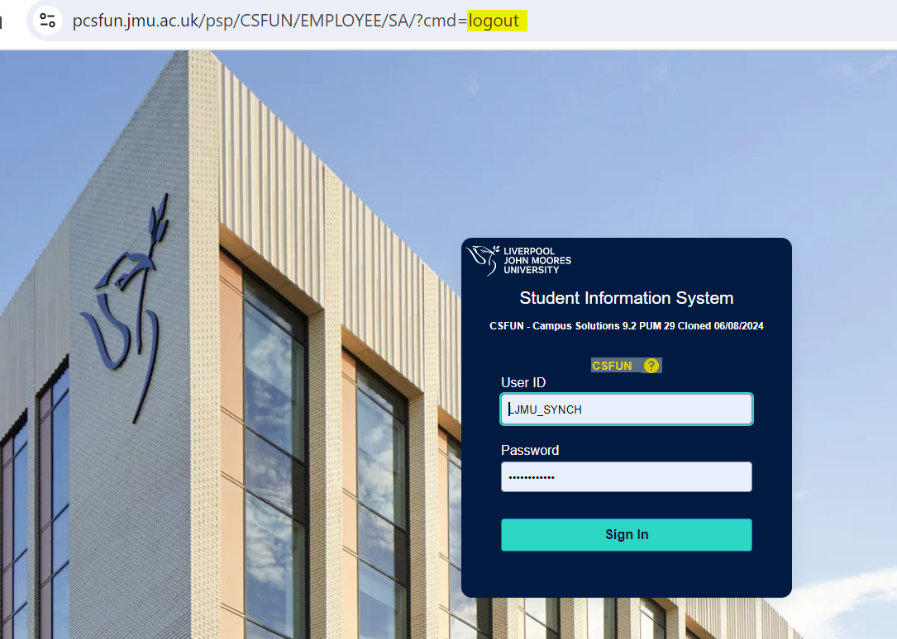

* **Details of Navigation Bar:**

When we click on **NavBar** icon, it will display options which contain Recently Visited, Favourites, Menu options.

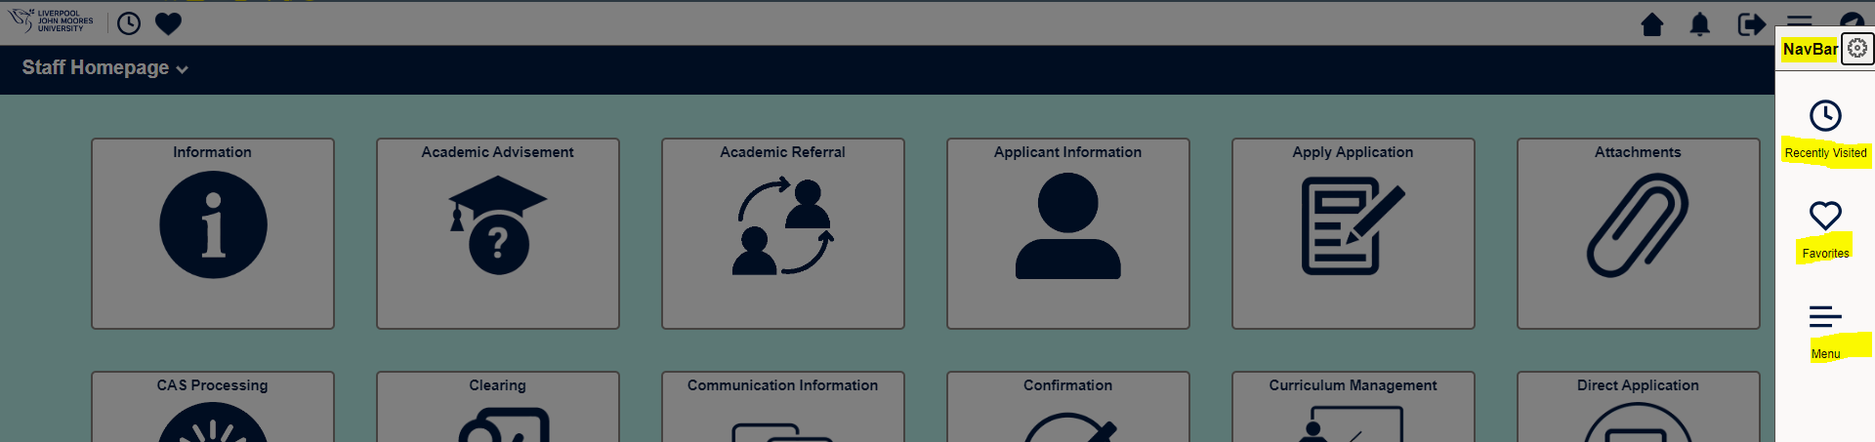

1. **Recently Visited** will show the pages which user Recently Visited.

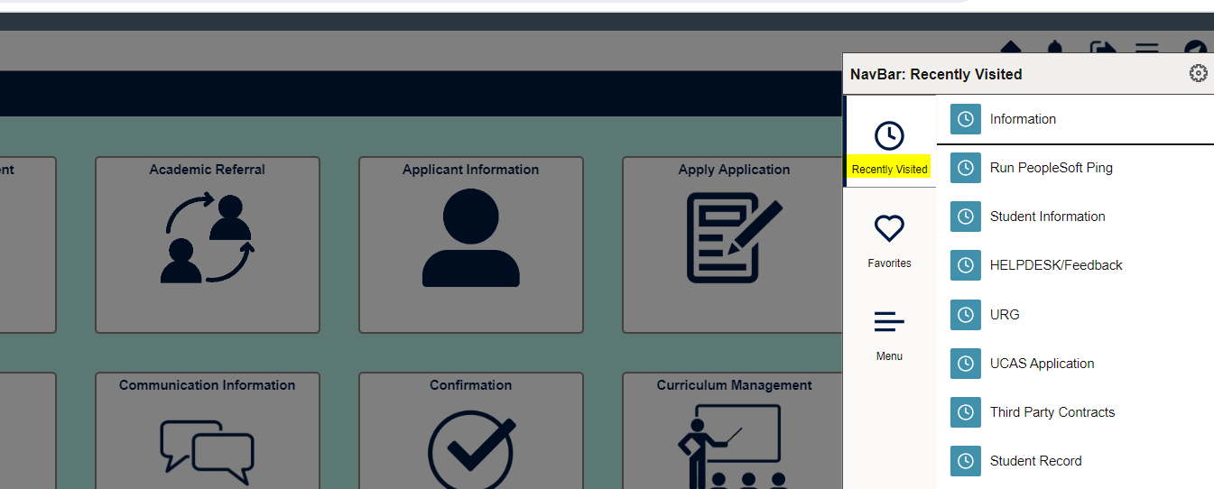

1. **Favourites** will show the pages which user added in Favourites.

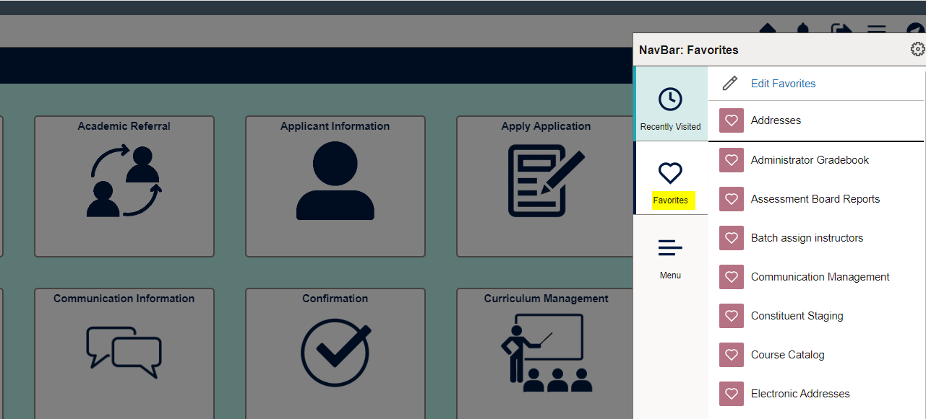

1. **Menu** option will have all the navigations user have access to same as the normal classic view.

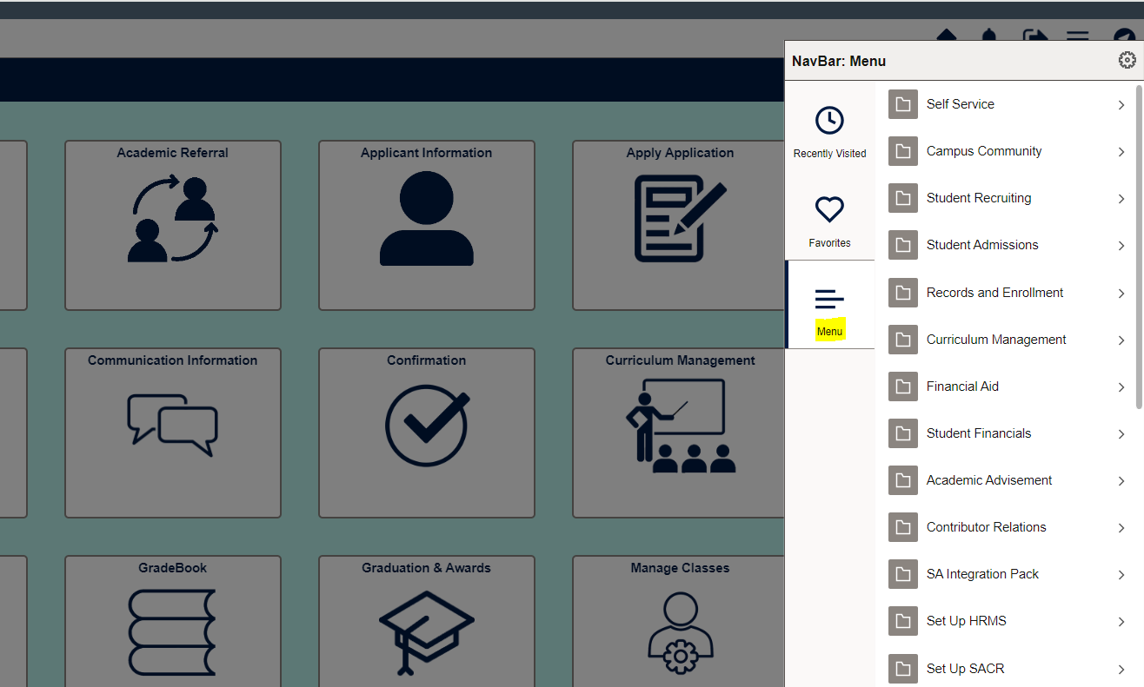

* **Add To Action:**

1. **Add to Homepage**
   1. We can add pages to favourites, Homepages, NavBar from below highlighted **Actions** button options:

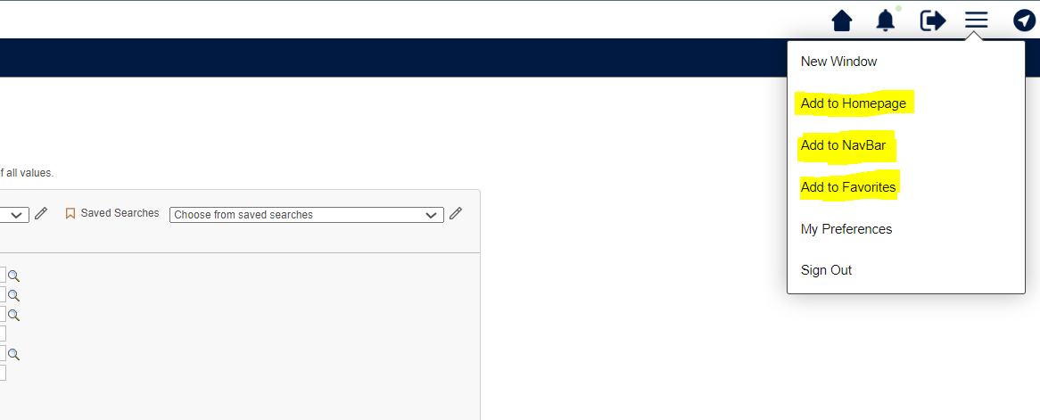

* 1. Click on **Add to Homepage** we need to select Homepage where we want to add this page.

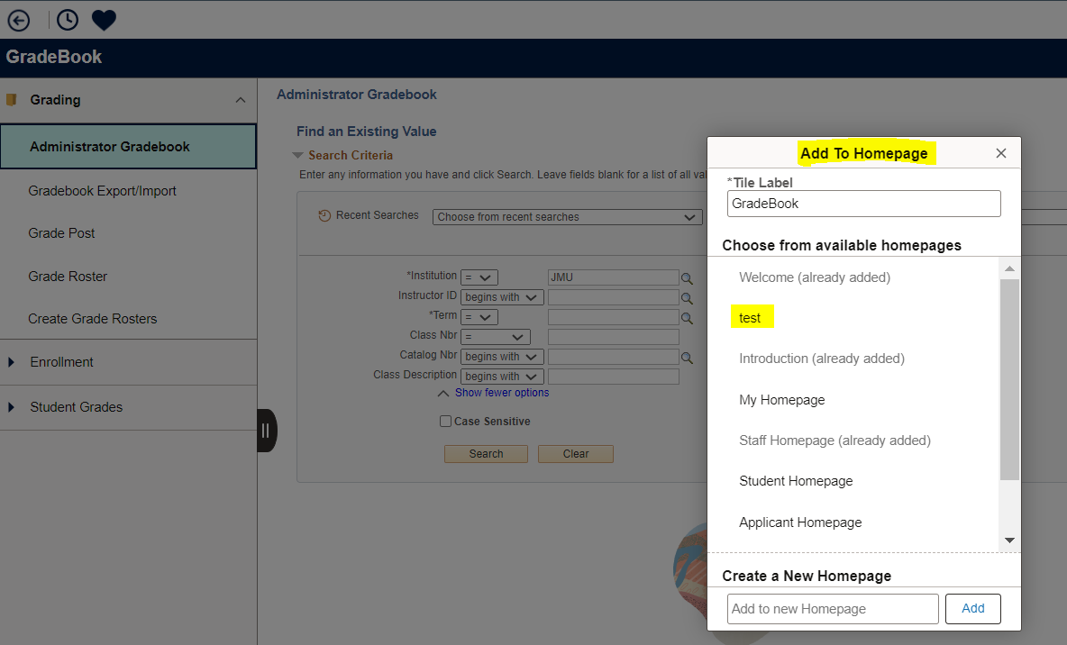

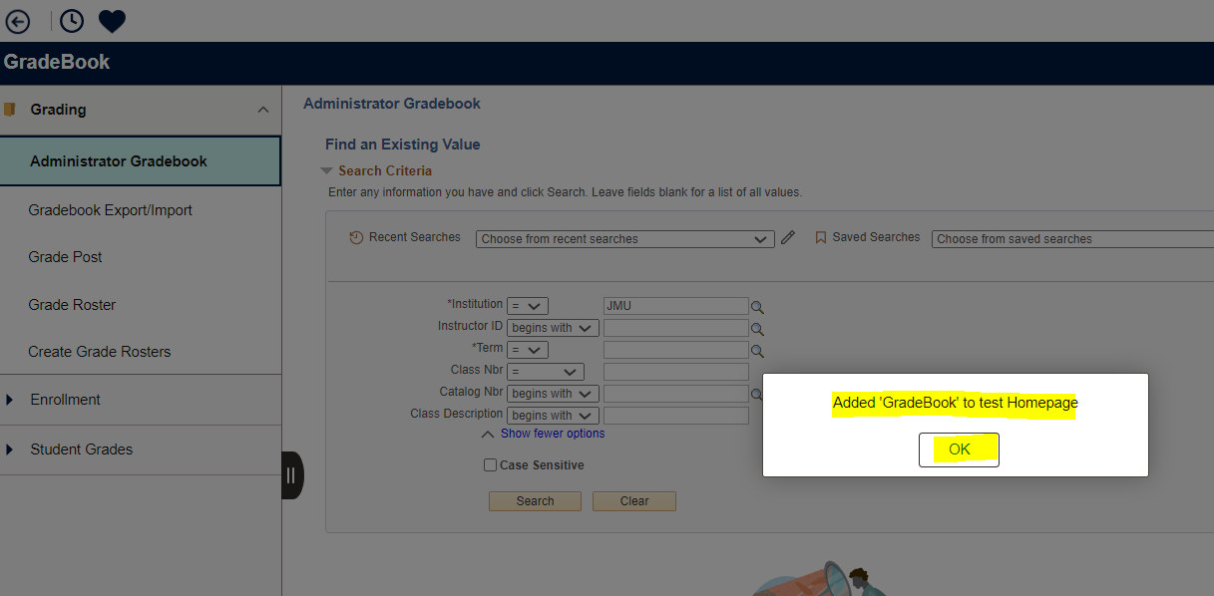

* 1. The tile added to Test Homepage

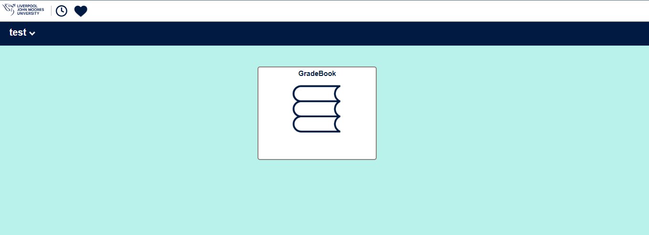

1. **Add to NavBar**
   1. Select Add to NavBar from Actions items.

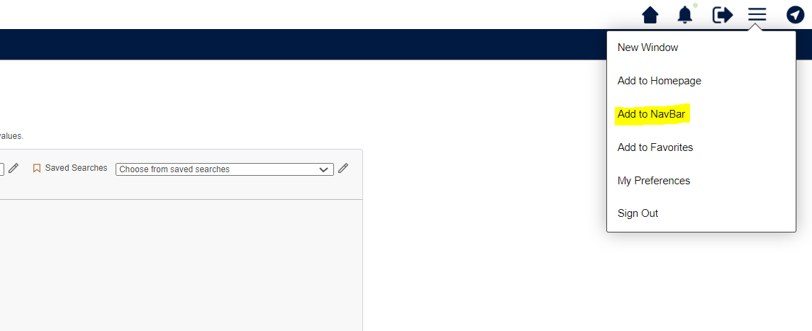

* 1. We can change the label if required and click on add.

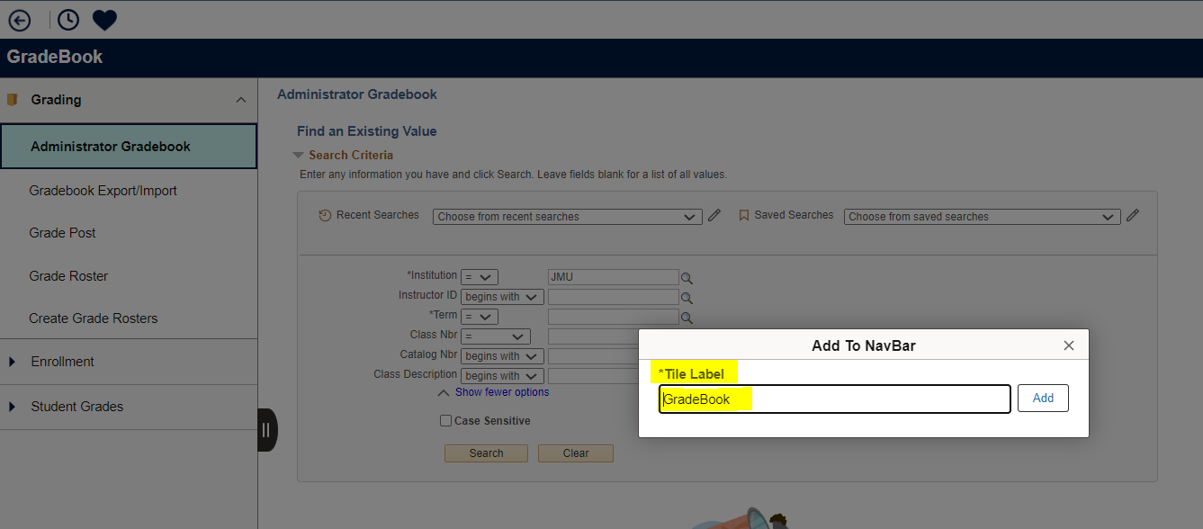

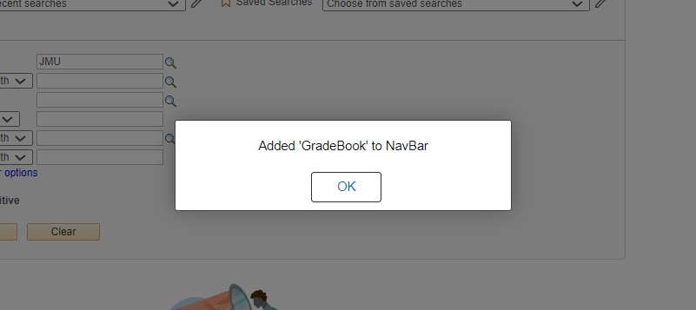

* 1. The Added tile is visible in NavBar.

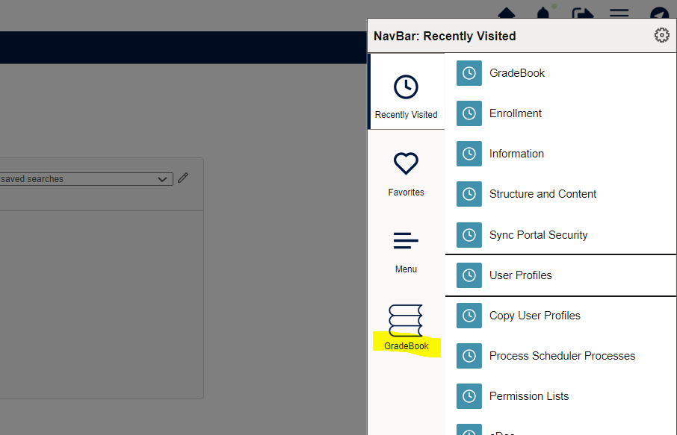

1. **Add to Favourites**
   1. Select Add to Favourites from Actions items.

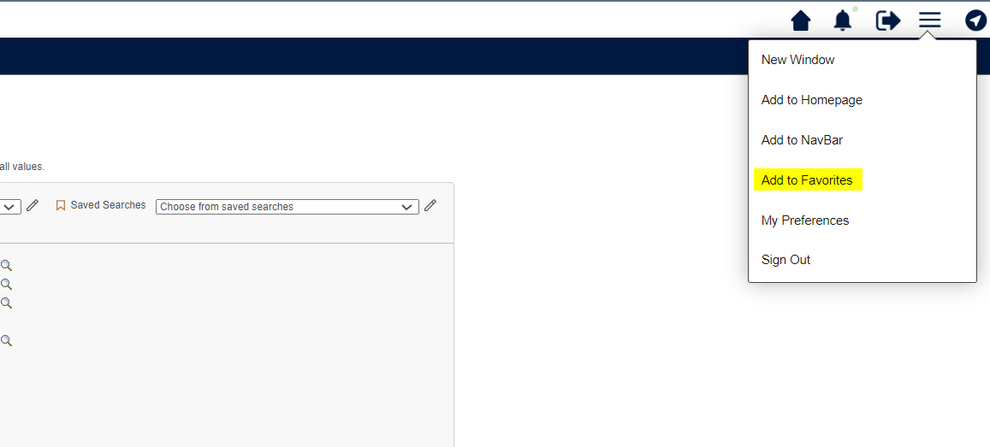

* 1. We can change the label and add tile.

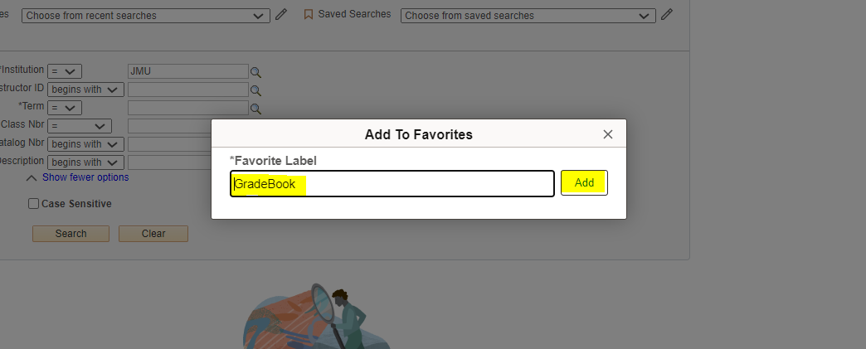

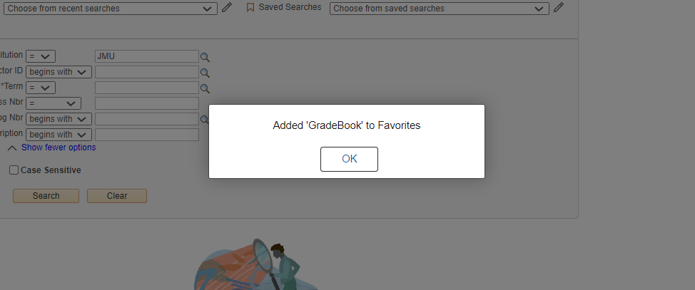

* 1. Added tile will be visible in Favourites.

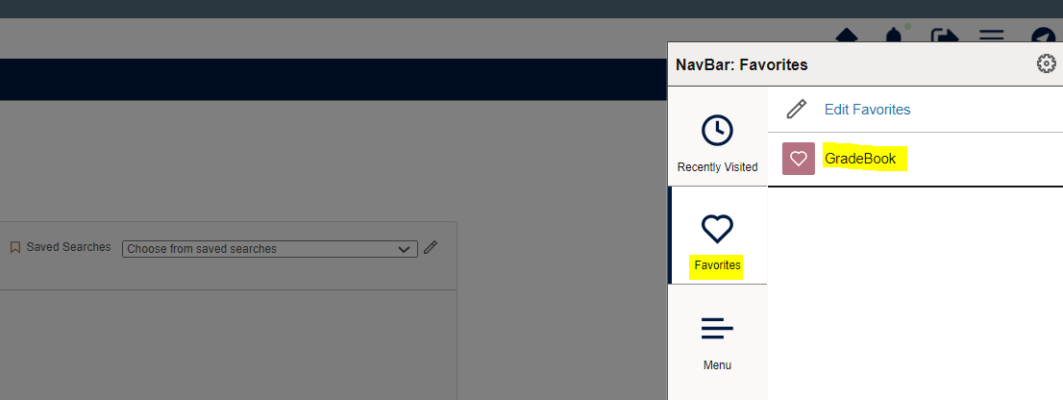

* **Personalize Homepage**

By clicking on the 3 dots in the homepage (  ) we can personalize our homepage. Here we can add new homepage and add tiles as per user need.

1. **Add new homepage:**
2. Click on 3 dots in homepage for personalization.

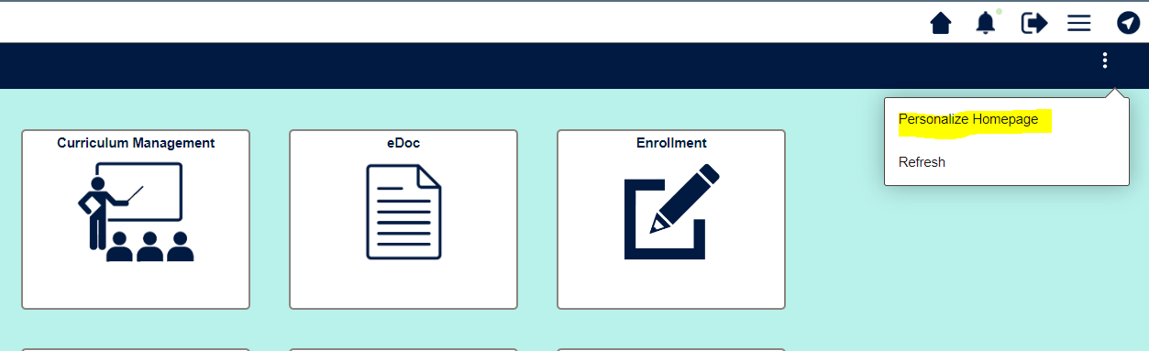

1. Add homepage.

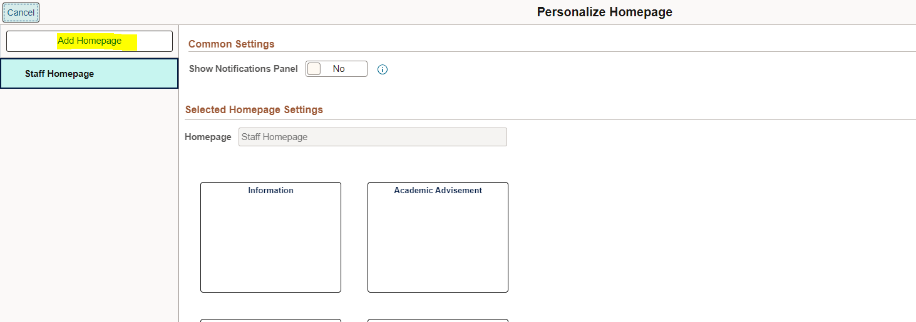

1. Add the new homepage name here.

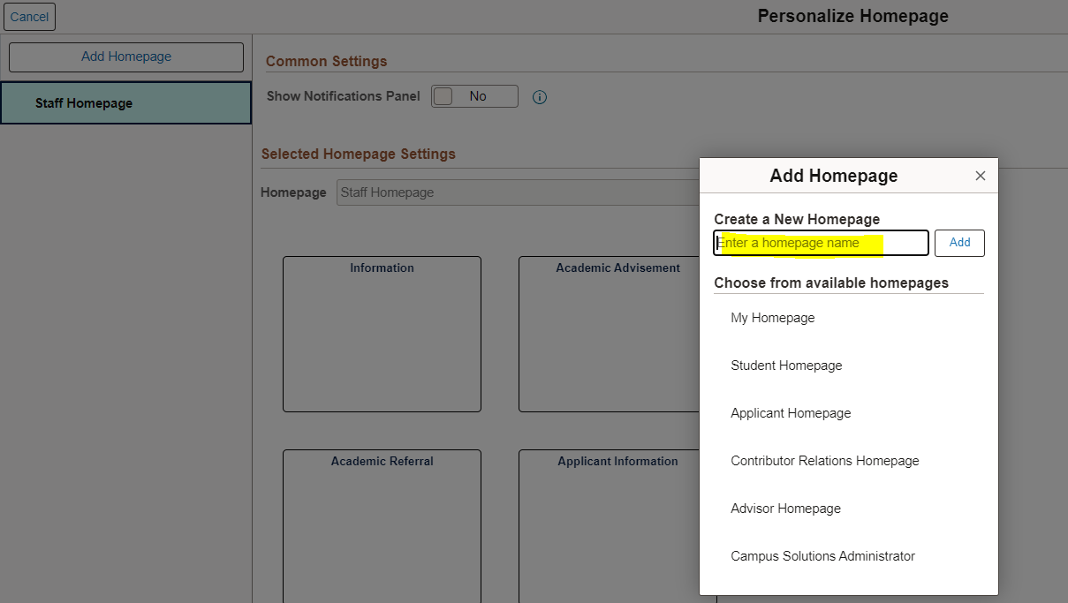

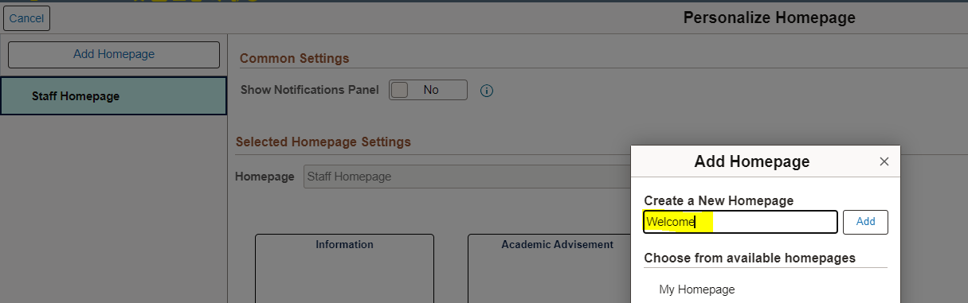

1. Click on Add and save it.

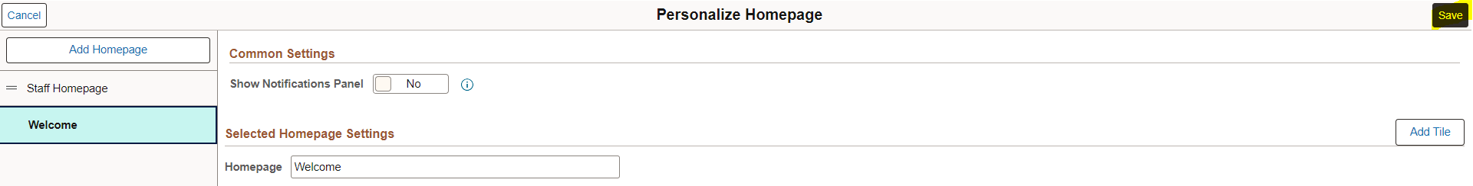

1. You will be able to see newly created homepage in dashboard.

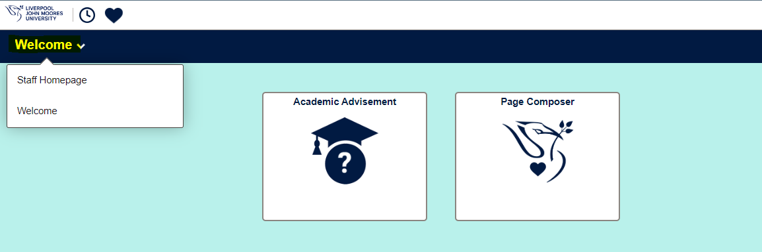

1. **Add Tiles to Homepage:**
2. Add Tile.

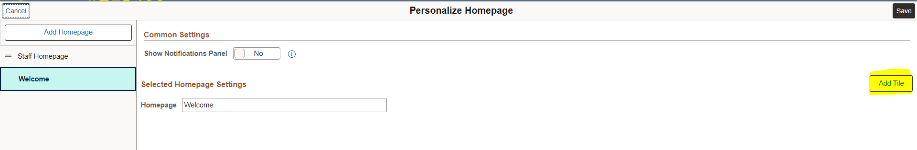

1. Select any tile that you want to add in your homepage.

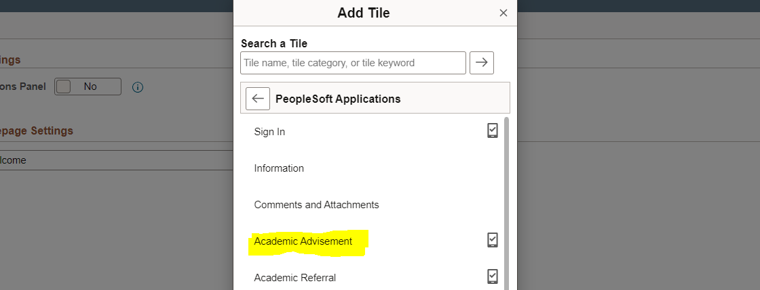

1. Save changes.

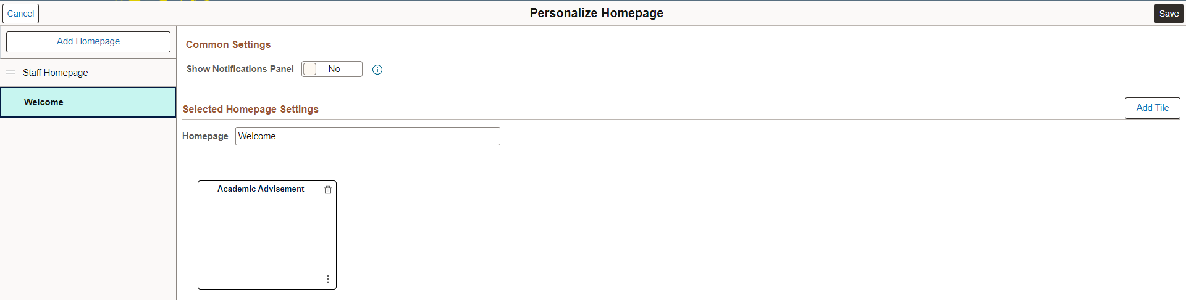

1. You can see the tile added in your homepage.

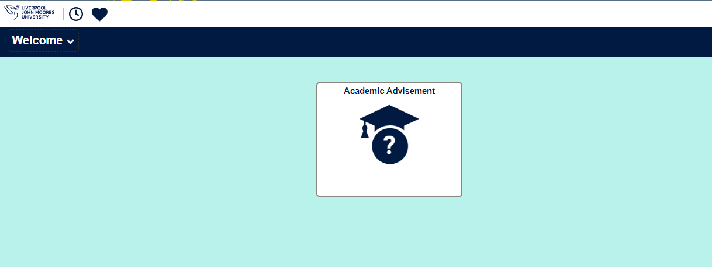

* **Tile with default Image.**

While adding tile for homepage if we do not select any image and that tile is not configured already it will display a default image.

* 1. Adding tile

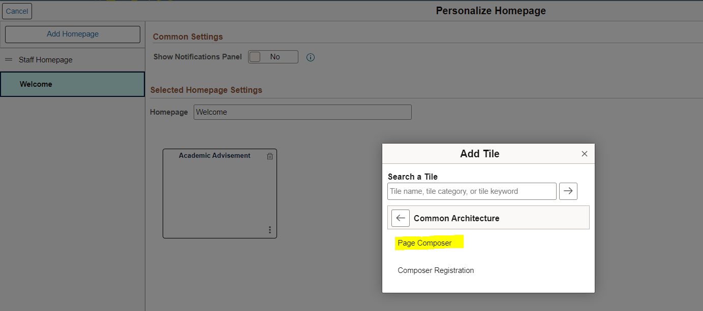

* 1. Save the changes.

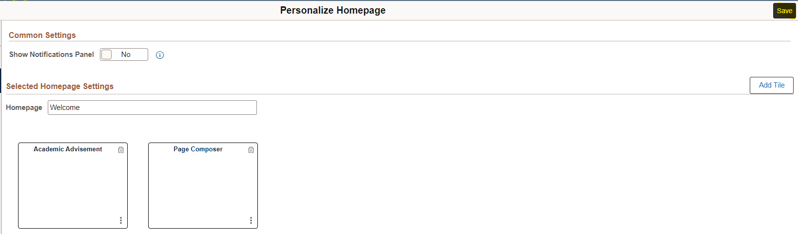

* 1. Default image got added for newly added tile Page Composer.

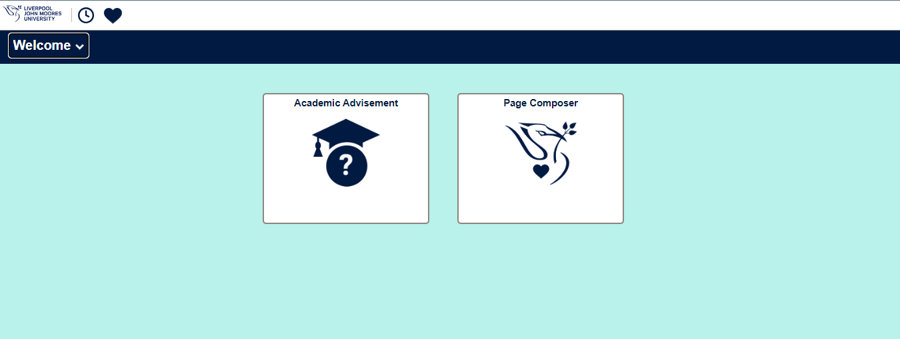

* **Copy Tile**

We can copy existing tile for other Homepages.

1. Click on personalize home page.

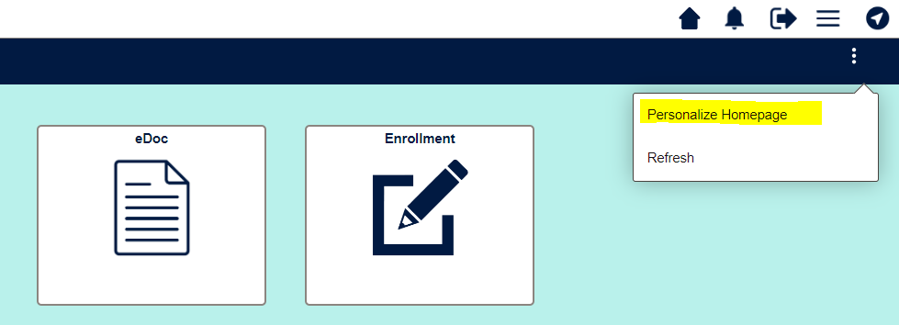

1. Click on the below highlighted 3 dots.

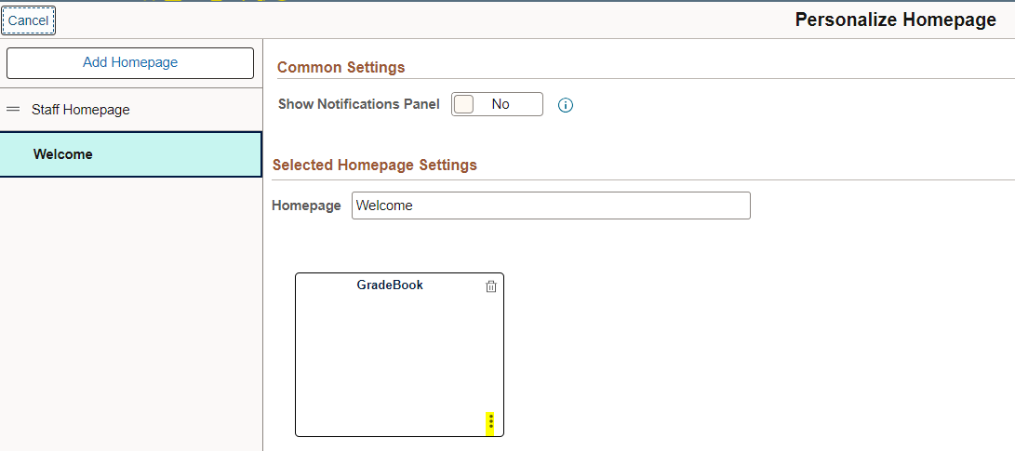

1. Click on the Copy To option.

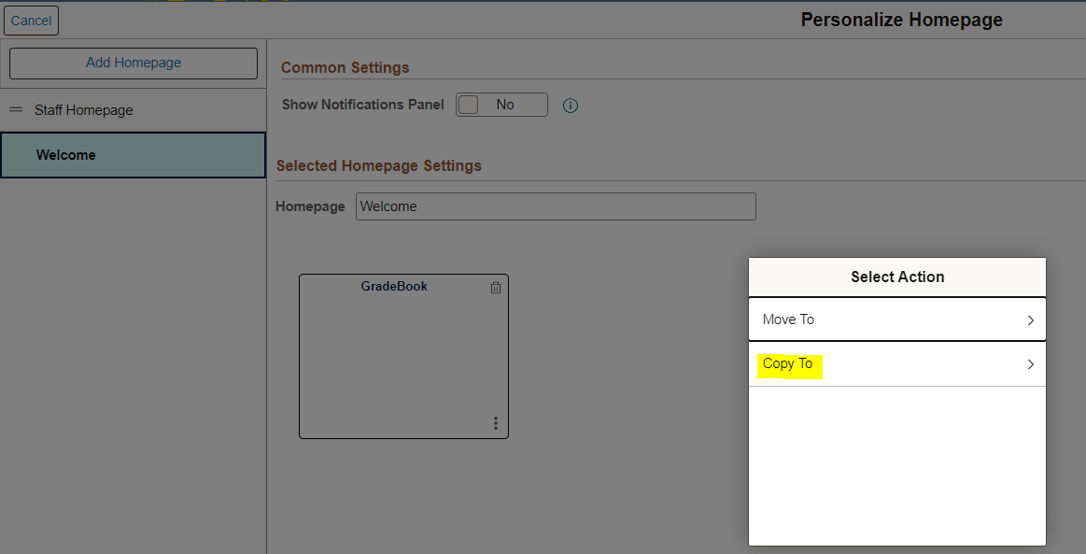

1. It will show you what all homepage we can copy this tile. Select Homepage.

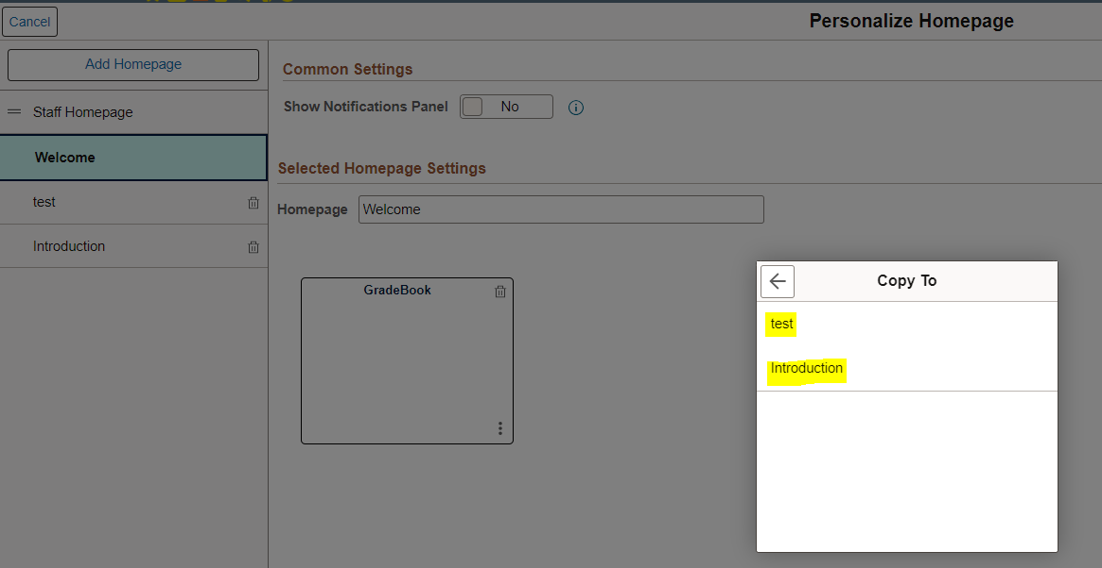

1. Copied tile you will be able to see in the selected Homepage.

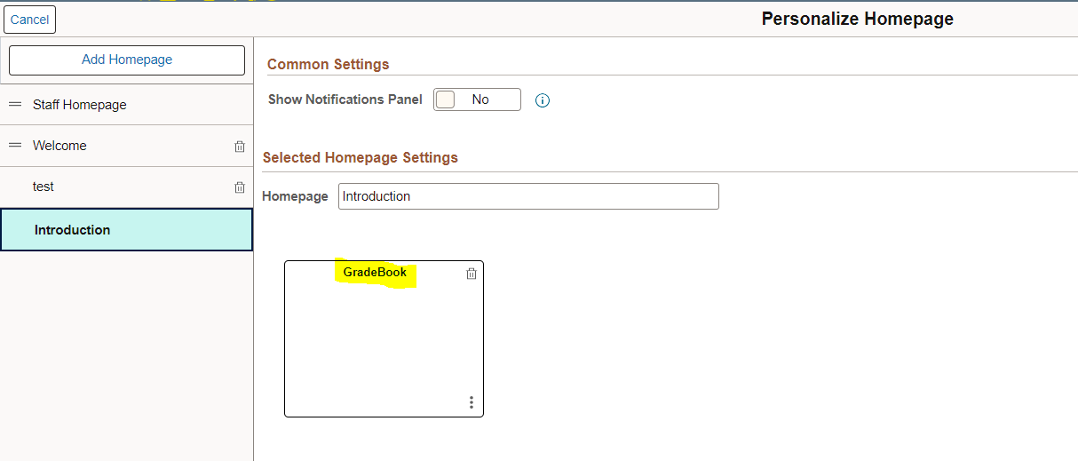

1. Save all changes.

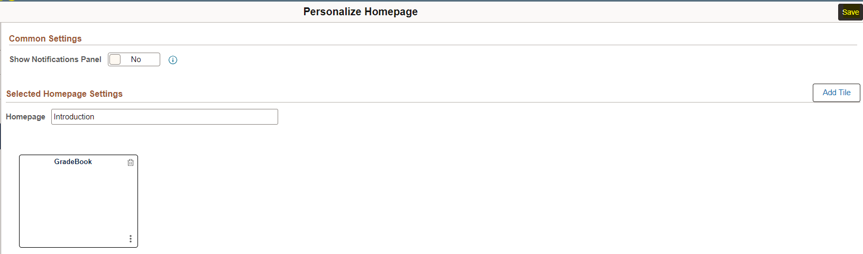

1. We will be able to see copied tile.

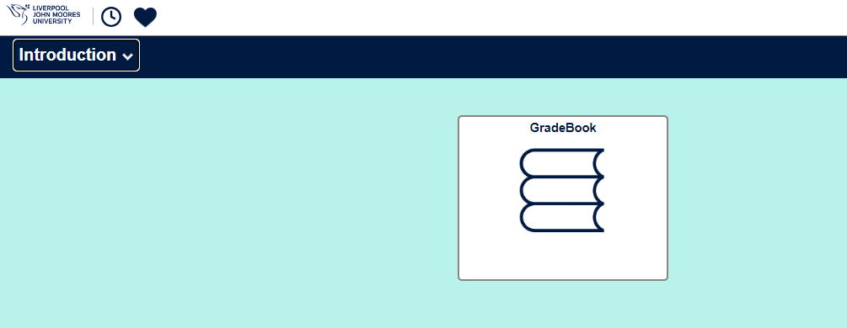

**Note: Staff Homepage** is a default home page, and we cannot delete that homepage.