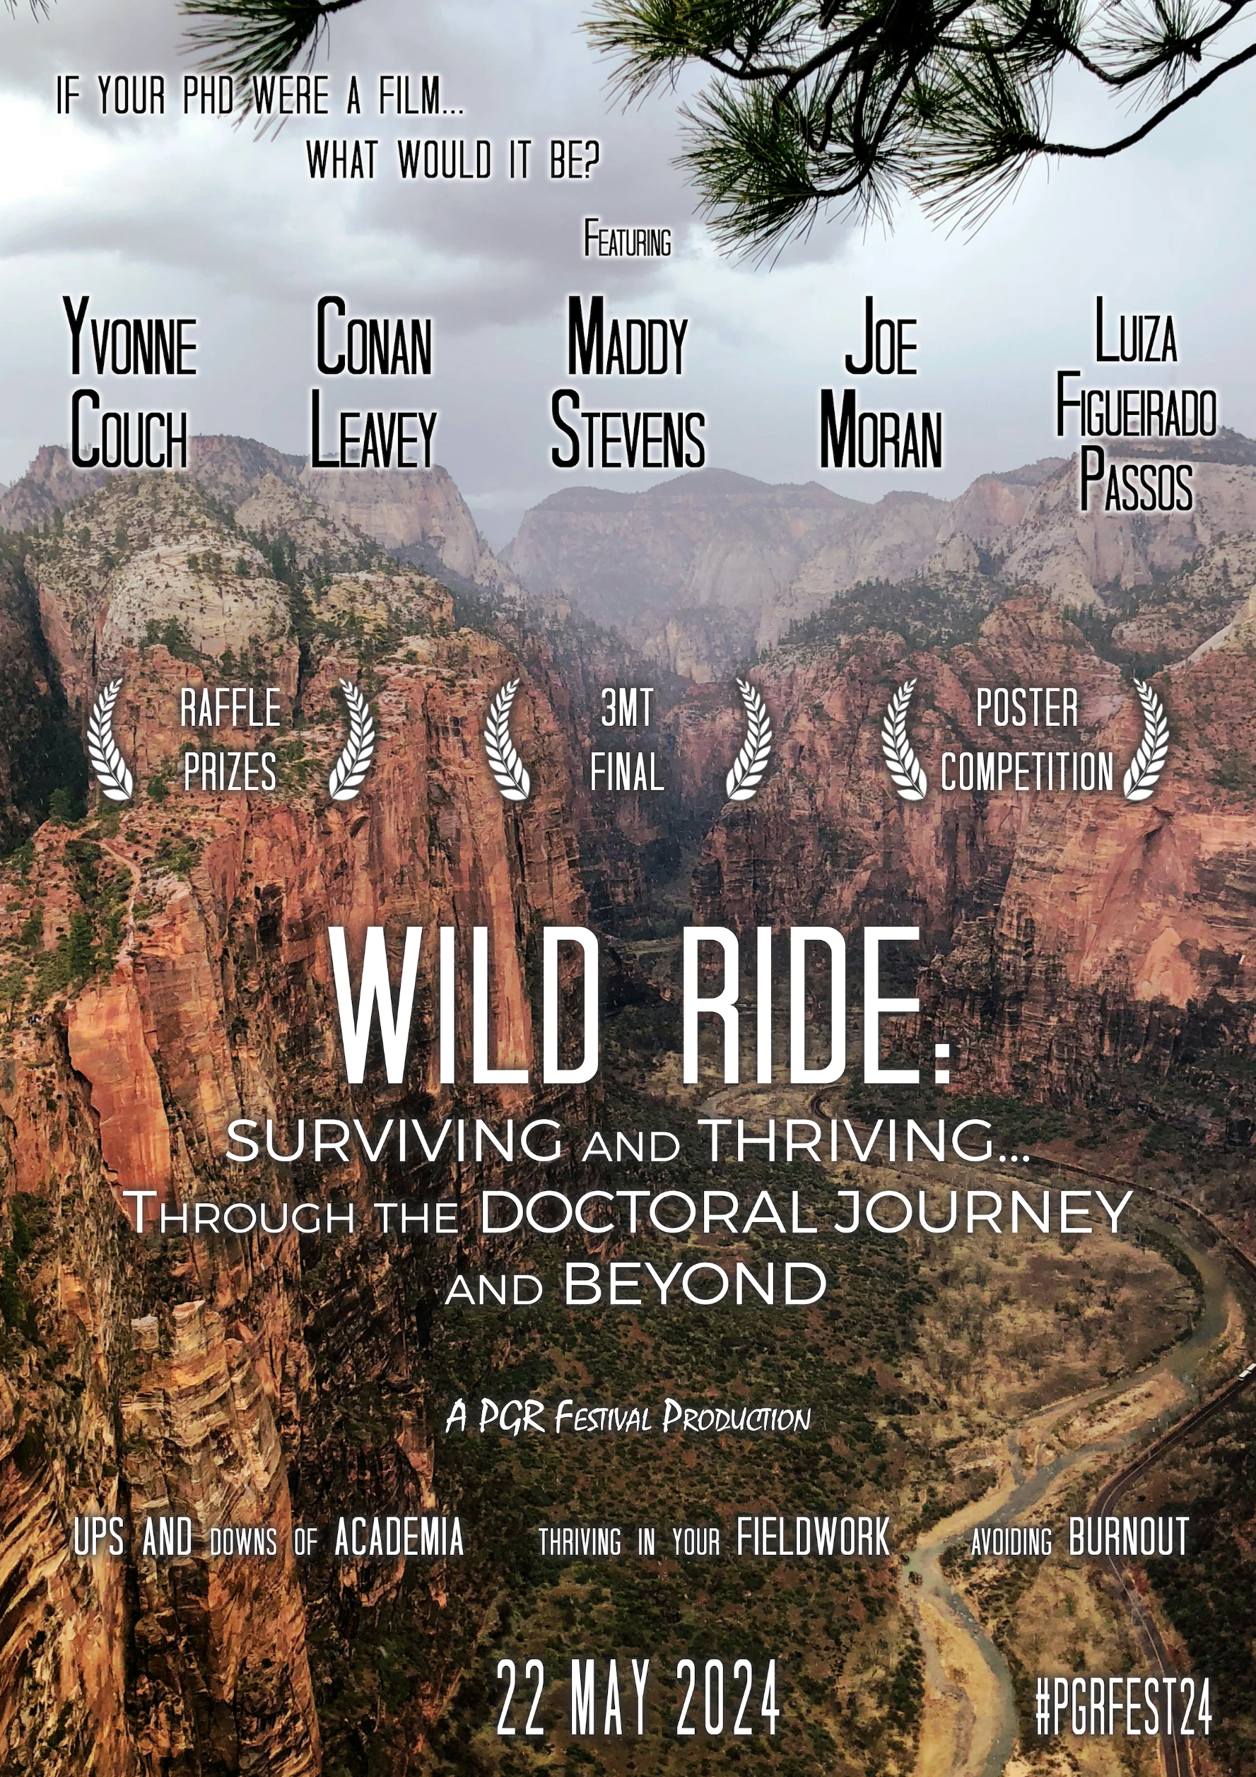
Welcome
The Doctoral Academy is delighted to welcome you to its annual festival of postgraduate research. The organisation of this festival has been led by our postgraduate researcher community. Our PGR Festival Coordinators have done an excellent job of putting together the exciting programme of speakers and presentations. Over 70 PGRs are sharing their research through posters and Three Minute Thesis presentations, and many more are contributing to the day by attending and supporting peers. We want to thank you all for sharing your time and expertise in making this important event possible.
Prof Julie Sheldon, Dean of The Doctoral Academy

The Festival Organising Committee warmly welcomes you to the 2024 Postgraduate Research Festival. This annual event celebrates each of you and the outstanding research you are conducting. You make LJMU a vibrant community.

We know that a PhD is more than just the hours dedicated to reading, writing, laboratory or fieldwork, navigating experiments, statistical analysis, or sifting through thousands of quotations. A PhD journey is far from linear; it is a Wild Ride. A ride where, by discovering more about the world and advancing knowledge, we learn more about ourselves. Through this year’s festival theme, Wild Ride: Surviving and Thriving... Through the Doctoral Journey and Beyond, we tried to capture the idea that a PhD is an adventure where one navigates the challenges and obstacles of doing research while thriving and becoming a well-rounded researcher. Each PhD journey is unique; akin to the various genres in cinema, every journey is dotted with scenes of documentary, action, thriller, drama, comedy, or fantasy, with all involved characters hoping for the happy end of manuscript approval, article publication, and successful Viva examination. So, if your PhD were a film, which one would it be?

We are eager to see you thrive during the Poster Presentations and Three Minute Thesis competition. Through interactive workshops led by esteemed LJMU academics, we aim to delve deeper into strategies for surviving our doctorates. We will also draw inspiration from our keynote speaker, Dr Yvonne Couch, from the University of Oxford. The festival will end with a celebration of our LJMU Postgraduate community during a raffle and a prize-giving ceremony.

Buckle up for this Wild Ride!

The Festival Organising Committee:
Irina Stadniciuc (School of Public and Allied Health)
Naomi Walsh (School of Biological and Environmental Sciences)
Elliot Mbeta (School of Pharmacy and Biomolecular Sciences)
Ingrid Boedker (School of Psychology)
Jamil Khazri (Business School)
Remi Adetayo (School of Education)
Programme
09:00-09:30
Registration
(Upper ground floor)

09:30-09:45
Welcome
PGR Festival Organising Committee
Prof Julie Sheldon
(208/209)

09:45-11:00
Three Minute Thesis (3MT) University Final
(208/209)

11:00-11:30
Break
(Upper Ground Floor)

11:30-12:30
Parallel Workshops #1
'How to Improve your Academic Writing' with Dr Conan Leavey (208/9)
or
'The Doctoral Rollercoaster: the ups and downs of working in academia and the corkscrews in between' with Dr Maddy Stevens (207)

12:30-13:30
Lunch and stalls
Exhibition stalls from The Brilliant Club, US-UK Fulbright Commission, The Pandemic Institute and lots more
(JMSU Activity room and upper ground floor)
13:30-14:30
Poster Session
(level 2 and room 206)

14:30-15:30
Parallel Workshops #2
'How to be an Academic Failure' with Prof Joe Moran
(208/9)
or
‘Thriving in your Fieldwork’ with Dr Luiza Figueirado Passos (207)

15:30-16:00
Break
(Upper ground floor)

16:00-17:00
Keynote Speaker
Dr Yvonne Couch, University of Oxford
'Academic Burnout: Signs, Symptoms and Sympathy',
(208/209)

17:00-17:30
Closing remarks and prize announcement
Prof Keith George, Pro-Vice Chancellor (Research & Knowledge Exchange)
Raffle
PGR Festival Organising Committee
(208/209)

17:30-18:30
Drinks reception
(Upper ground floor)

Three Minute Thesis Final

Judges
Prof Keith George, Pro-Vice Chancellor (Research & Knowledge Exchange)
Dr Komang Ralebitso Senior, Pharmacy & Biomolecular Sciences
Dr Katrina Roberts, Head of Tutor Engagement, The Brilliant Club
Katherine Stephan, Research Support Librarian
1. Gemma Dale (Business School) |  | Exploring employee wellbeing and remote work. Developing an organisational framework for healthy hybrid work
2. Mark Arnold (Nursing & Advanced Practice) |  | Case study: how do residents transition between their care home and the emergency department?
3. Naomi Walsh (Biological and Environmental Sciences) |  | AI enhanced camera monitoring for zoological collections: assessing behaviour and welfare
4. David Hitchmough (Engineering) |  | Air lubrication: is it all air under the ship?
5. Remi Adetayo (Education) |  | Evaluating the integration of digital pedagogies in the Continuing Professional Development of English language academic staff: a case study of three Nigerian universities
6. Olivia Brennan (Law) |  | Questions of identity: the problem of internal self-determination in international law
7. Louise Rimmer (Screen School) |  | The song of fallen angels: telling the terrorist’s story
8. K-Ryan Hinds (Astrophysics) |  | Cosmic catastrophe: analysing core-collapse supernovae
9. Ravija Ravindra Kadam (Pharmacy & Biomolecular Sciences) |  | The quest for flawless skin: future or futile?
10. Libby Robinson (Education) |  | Exploring the benefits of having a sensory hub at LJMU
11. Jessa Mae Canas (ENR) |  | Computational wear analysis of shoulder replacements
12. Andrew Munro (Law) |  | Economic and social rights and the limits of law
13. Ingrid Boedker (Psychology) |  | Infant sleeping location and touch-mediated mother-infant outcomes: Liverpool night-time caregiving study
14. Zoe Bell (Sport & Exercise Sciences) |  | Improving the working conditions and health of contact centre advisors
3MT People’s Choice Award

Scan the QR code to vote for the People’s Choice 3MT winner
Or go to http://bit.ly/PGR3MT24

Voting is open from 9:30-11.30am

Posters
Posters will be on display throughout the day. There is a poster session from 13:30-14:30 during which judging takes place and delegates can talk to poster presenters about their research.
Posters are ordered alphabetically by title.
Early-stage PGR posters (1st year or part-time equivalent)

1.Avni Gupta (Biological & Environmental Sciences) | Biotechnological interventions for improving seed oil traits and biodiesel properties in moringa oleifera lam
2. Md Meraz Ahmed (Education) | Blended teacher education model to achieve SDG4 in least developed countries
3. Katie Crawford (Biological & Environmental Sciences) | Can plasticity in hibernation behaviour help European hedgehogs adapt to urbanisation?
4. Beth Smith (Psychology) | Communication and blended-learning: gaze cues in different learning contexts across educational stages
5. Bethany Shackleton (Biological & Environmental Sciences) | Developing an approach for assessing the welfare of wild birds through the use of bioacoustics analysis
6. Zhitian Hu (Biological & Environmental Sciences) | Environmental impacts on fruit fly sleep: a meta-analysis approach
7. Maria Planes Alias (Psychology) | Exploring the role of empathy in interactions between healthcare professionals and people with fibromyalgia
8.Sarah Stanley (Nursing & Advanced Practice) | Exploring digital legacy in palliative care… Consider the legacy on your mobile phone!
9. Lauren Comerford (Psychology) | Exploring the mental health experiences of late diagnosed autistic adults
10. Michele Goodbody (Law) | Gender critical speech, social media, and misogyny: a human rights approach to hate in the UK
11. Rio Foster (Psychology) | Green social prescribing: can nature-based, non-clinical community assets improve children and young peoples mental health?
12. Sadie Walton (Business School) | Grounds for direct trade? Global value chains, responsible sourcing and how stakeholders can benefit
13. Sarah Klingberg (Justice Studies) | Lost in translation: examining the risks of unaccompanied migrant children going missing in the UK
14. Stacy Hughes (Education) | Peer observations- the good the bad and the ugly. Changing the game with P.O.P genealogy
15. Jamie Williams (Pharmacy & Biomolecular Sciences) | Peptide functionalised nanoparticles for co-delivery of siRNA and methotrexate for the treatment of psoriasis
16. Adam Crockett (Pharmacy & Biomolecular Sciences) | Peptide-targeted RNA nanotherapeutics for chronic wound healing
17. Farhan Ahmed (Civil Engineering & Built Environnent) | Performance and design of structural components of Modular Metal Frame Structures (MMFS), in the context of net zero and affordable housing
18. Zoe Torsney (Education) | Powering up or powering through? Experiences of key adults supporting autistic children via an EHCP
19. Elliot Mbeta (Pharmacy & Biomolecular Sciences) | Prediction of outcomes in patients with hypertension using clinical laboratory biomarkers - a real-world analysis using a global federated database
20. Jiata Ekele (Biological & Environmental Sciences) | The CO2 paradox: does climate change affects the nutritional quality of crops?
21. Sophie Laidlaw (Biological & Environmental Sciences) | The resilience of community led flood groups in the North West
22. Isla Bottling (Biological & Environmental Sciences) | To move or knot to move: individual variation in islandica red knot movement in the overwintering season
23. Lauren Tonge (Pharmacy & Biomolecular Sciences) | Towards targeted RNA delivery for scarring alopecia therapy
24. Derya Kavuncu (Nursing & Advanced Practice) | Virtual Reality as a method of pain and delirium management
25. Madeline Rowe (Psychology) | Women’s alcohol use in midlife: associations between stages of menopause, health, and wellbeing
26. Emily Williams (Engineering) | You wouldn't steal a face

Mid- and Later-stage PGR posters

1. Paul Edwards (Justice Studies) |  | A criminological analysis of television crime dramas
2. Salma Shalaby (Screen School) |  | Beyond the screen: virtual visions for suicide prevention
3. Evieva Ogbara (Pharmacy & Biomolecular Sciences) |  | Biochar-mediated paphthalene degradation: microcosm study unveils catechol pathway and microbial community dynamics
4. Shelley O’Connor (Nursing & Advanced Practice) |  | Capturing the student experience of the doctoral journey
5. Gabriela Chronowska-Bojczuk (Pharmacy & Biomolecular Sciences) |  | Characterising the microbial biodegradation of polystyrene
6. Shaunna Devine (Psychology) |  | Childhood trauma shapes attitudes and experiences of social touch
7. Gemma Farrington (Biological & Environmental Sciences) |  | Circadian dynamics in an in vitro model of cutaneous wound repair
8. Jenna Rice (Sport & Exercise Sciences) |  | Co-development of a gamified movement competence PE Intervention
9. Kyle Tyler (Pharmacy & Biomolecular Sciences) |  | CRISPR-ing cassava: hacking cassave for a speedier spud
10. Jonah Conley (Astrophysics) |  | Emulating the cosmos: predicting the non-linear effects of matter clustering from multi-fidelity simulations
11. Rashmi Danwaththa Liyanage (Psychology) |  | Ethnic mental health inequalities: understanding whether discrimination causes psychosis among people from ethnic minority backgrounds
12. Remi Adetayo (Education) |  | Evaluating the integration of digital pedagogies in the Continuing Professional Development of English language academic staff: a case study of three Nigerian universities
13. Zoe Bell (Sport & Exercise Sciences) |  | Exploring the perceived effectiveness of contact centre health initiatives
14. Dave Nwosu (Engineering) |  | Failure modes and effect analyses for renewable minigrids
15. Giada Vincentini (Human Sciences, University of Verona) |  | Improving emotional competence in early adolescence: a school-based intervention
16. Ian Eustace (Nursing & Advanced Practice) |  | Integrated care management for patients following acute stroke: evidence synthesis and development of a novel holistic approach to stroke care
17. Silvia Cont (Education) |  | ITE trainee teachers’ experiences of Forest School training Level 1: suggestions improvement and policies development
18. Hui Liu (Business) |  | Investigating pre-loved luxury fashion consumption: evidence from the Chinese consumers
19. Laura Kinsey (Nursing & Advanced Practice) |  | Living with complex congenital heart disease (CHD) as an adolescent or a parent
20. Sylvia Augustine (Sport & Exercise Sciences) |  | Markerless motion capture: assessing gait kinematics reliability and validity
21. Eleanor Cantwell (Sport & Exercise Sciences) |  | Psychosocial factors in talent development within the British Gymnastics performance pathway
22. Connie Pike (Justice Studies) |  | Recovery ready research: a framework to ensure that the methods we adopt to research recovery communities are indeed recovery ready
23. Carol Ryder (Art & Design) |  | Season's Greetings
24. Paul French (Law) |  | Social media enabled moral panic and conspiratorial credulity
25. Caighley Logan (Pharmacy & Biomolecular Sciences) |  | Temperature related alterations to mineral levels and crystalline structure in porcine long bone: intense heat vs. open flame
26. Rebecca Kuiper (Psychology) |  | Testing the functional near infrared spectroscopy to detect neurocognitive differences across social drinking patterns
27. Thomas Daley (Pharmacy & Biomolecular Sciences) |  | The importance of CCL19, CCL21 and TNF-α in dendritic cell development
28. Louise Rimmer (Screen School) |  | The song of fallen angels: telling the terrorist's story
29. Ali Atashbarg (Sport & Exercise Sciences) |  | The use of AI technologies to optimise exercise and physical activity interventions for people with long-term conditions
30. Molly Hawker (Computer Science & Mathematics) |  | Turning biological experiments into mathematical equations: a hybrid stochastic system of calcium puffs
31. Norliza Mohd Salleh (Sport & Exercise Sciences) |  | Unveiling physical activity challenges in gestational diabetes mellitus pregnancy: a qualitative exploration
32. Richard Murray (Sport & Exercise Sciences) |  | VAR's treacherous journey so far
33. David Furlong (Psychology) |  | What is consciousness?
Poster Judges
Prof Hazel Andrews, Faculty of Business and Law
Dr Theo Bampouras, Faculty of Science
Cath Dishman, Library Services
Dr Catrin Eames, Faculty of Health
Prof Ian Fillis, Faculty of Business and Law
Dr Michaela Gkantou, Faculty of Engineering and Technology
Elysia Greenway, Faculty of Arts, Professional and Social Studies
Dr Paddy Hoey, Faculty of Arts, Professional and Social Studies
Dr Mike Hollows, Faculty of Arts, Professional and Social Studies
Dr Adam Knowles, Impact, Research and Innovation Services
Dr Katrina Roberts, The Brilliant Club
Dr Sam Roberts, Faculty of Health
Dr Molly McCarthy, Faculty of Health
Dr Rhian Wyn-Williams, Academic Achievement

Speakers
Keynote Speaker: Dr Yvonne Couch
Yvonne is an Associate Professor of Neuroimmunology in the Radcliffe Department of Medicine at the University of Oxford. Her research focuses on how the brain communicates injury or illness to the systemic immune system, and vice-versa. In 2020 she was awarded an Alzheimer’s Research UK Fellowship to study the effect of extracellular vesicles (EVs) on endothelial cells in the context of vascular dementia. She is currently working on a British Heart Foundation Transition Fellowship to study metabolism in the brain after stroke. She continues to work closely with the Dementia Researcher community based out of UCL and regularly talks about science, scientific culture and career topics in blogs and podcasts for the Dementia Researcher Network.

Workshop Facilitators
Dr Conan Leavey, Public and Allied Health, Faculty of Health
Conan is a PGR Co-ordinator for the School of Public and Allied Health. His teaching and research areas include qualitative research methods, cross-cultural approaches to health, and violence as a public health issue. He has supervised a wide range of PhD projects and is a Recognised Supervisor with the UK Council for Graduate Education. Conan completed an MA in Writing in 2010, missing a distinction by 1%. He has learned to let it go.

Dr Maddy Stevens, Liverpool Business School, Faculty of Business and Law
Maddy is a Reader in Organisational Transformation and Teaching Innovation. She teaches on the Human Resource Management Programme and has over twenty years of experience as a HR practitioner. Her research focuses on the impact of redundancies on organisations and people.

Prof Joe Moran, Humanities and Social Science, Faculty of Arts Professional and Social Studies
Joe is a Professor of English and Cultural History at LJMU. His most recent books are Shrinking Violets: The Secret Life of Shyness (2016), First You Write a Sentence (2018) and If You Should Fail: A Book of Solace (2020). He writes regularly for magazines and newspapers such as The Guardian, The Observer, TLS and The London Review of Books.

Dr Luiza Figueirado Passos, School of Biological and Environmental Sciences, Faculty of Science
Luiza is based in the School of Biological and Environmental Sciences and is a member of the LJMU Biodiversity and Conservation Group. Her research focuses on the golden mantilla frog, a species endemic to Madagascar and the Jamaican Anole. Her PhD investigated the behavioural skills of reptiles and amphibians in zoos and how this would affect their survivorship in the case of a reintroduction to the wild. During this research she sampled both from wild and zoo populations to produce a database for future comparisons.

PGR Festival Organising Committee
Remi Adetayo
Remi is a third-year PhD student in the School of Education. Her research evaluates the integration of digital pedagogies in the CPD of English language academic staff, through a case study of three Nigerian universities. Remi has taught in Nigerian Navy schools for over 19 years and worked as a Grade 1 Staff Officer Training and Support in the Nigerian Navy Education head office before starting her PhD program in the UK.
Ingrid Boedker
Ingrid is a PhD student in Psychology and Neuroscience and the Principal Investigator of the Liverpool Night-time Caregiving Study. Her research focuses on different infant sleeping arrangements and associated outcomes for mothers and infants, and how these outcomes are mediated by touch behaviours. She is a member of SomAffect and the Durham Infancy and Sleep Centre.
Jamil Khazri
Jamil is in the second year of his PhD in the Business school. His research is based in an Atlas Mountains village in north-western Tunisia and focuses on the intersections between heritage sites, colonialism, memory and folklore.
Elliot Mbeta
Elliot is a first year PhD researcher in the School of Pharmacy and Biomolecular Sciences, on the ‘Misconceptions in the Treatment of Hypertension (MITH)’ Thematic Doctoral Pathway, supervised by Dr Garry McDowell. He holds an MSc in Public Health (MPH-Epidemiology and Biostatistics) from University College Cork, Ireland and a BSC in Nursing.
Irina Stadniciuc
Irina is in the first year of her PhD in the Faculty of Health, researching the Romanian prison experience. She is the PGR Representative for the School of Public and Allied Health and is dedicated to contributing to a vibrant research community at LJMU.
Naomi Walsh
Naomi is a second year PhD PhD Researcher in the School of Biological and Environmental Sciences. Her research focuses on technology for zoo research and she sits on a number of zoo research focused committees.

PGR Festival Raffle: a message from the PGR organisers
Thinking about LJMU’s strong community ties as a modern civic University, we wanted to use this year’s Festival as a platform for the greater good. Therefore, we have partnered with The Whitechapel Centre, which is the leading homeless and housing charity for the Liverpool region. Whitechapel work with people who are sleeping rough, living in hostels or struggling to manage their accommodation. They are committed to helping people find and maintain a home and learn the life skills essential for independent living. We hope you will visit Whitechapel’s stand to learn more and to participate in our charity raffle! Raffle tickets cost just £1 per entry, and all the money raised will go directly to Whitechapel.

We could not have organised this raffle without the support of local businesses who donated raffle prizes. Thank you so much!

We would also like to thank Abode Estate Agents for pledging to donate to Whitechapel on behalf of this event. Finally, we would like to thank the Doctoral Academy for their continued support, and for donating a Gladstone’s Library voucher as a raffle prize.

The PGR Festival Organising Committee: Naomi Walsh, Elliot Mbeta, Irina Stadniciuc, Ingrid Boedker, Jamil Khazri, and Remi Adetayo

